**Experiment No.-2**

**Student Name: PUJA KUMARI UID: 20BCA1448**

**Branch: BCA Section/Group: 20BCA5-B**

**Semester: 5th Date of Performance: 1.9.22**

**Subject Name: COMPUTER GRAHICS LAB Subject Code: 20CAP-316**

1. **Aim/Overview of the practical:** Write a program to using mid-point circle drawing algorithm.
2. **Task to be done:** Using the algorithm draw the circle.
3. **Concept used:**

**Algorithm for Mid-Point Circle Drawing**

**Step1:** Put x =0, y =r in equation 2  
            we have p=1-r

**Step2:** Repeat steps while x ≤ y  
            Plot (x, y)  
            If (p<0)   
Then set p = p + 2x + 3  
Else  
            p = p + 2(x-y) +5  
            y =y - 1 (end if)  
            x =x+1 (end loop)

**Step3:** End

1. **Steps/Commands involved to perform practical:**

#include<stdio.h>

#include<conio.h>

#include<graphics.h>

void drawcircle(int x0, int y0, int radius)

{

int x = radius;

int y = 0;

int err = 0;

while (x >= y){

putpixel(x0 + x, y0 + y, 7);

putpixel(x0 + y, y0 + x, 7);

putpixel(x0 - y, y0 + x, 7);

putpixel(x0 - x, y0 + y, 7);

putpixel(x0 - x, y0 - y, 7);

putpixel(x0 - y, y0 - x, 7);

putpixel(x0 + y, y0 - x, 7);

putpixel(x0 + x, y0 - y, 7);

if (err <= 0){

y += 1;

err += 2*y + 1;

}

if (err > 0)

{

x -= 1;

err -= 2*x + 1;

}

}

}

int main()

{

int gdriver=DETECT, gmode, error, x, y, r;

initgraph(&gdriver, &gmode, "");

printf("Enter radius of circle: ");

scanf("%d", &r);

printf("Enter co-ordinates of center(x and y): ");

scanf("%d%d", &x, &y);

drawcircle(x, y, r);

getch();

return 0;

}

1. **Result/Output/Writing Summary:**

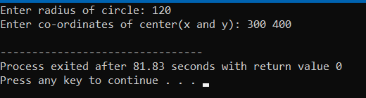

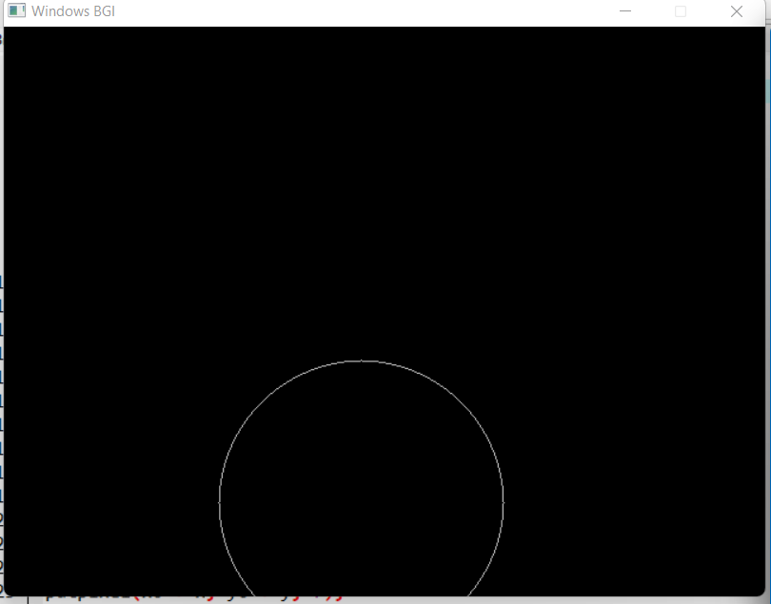

**Learning outcomes (What I have learnt):**

1. I have learnt about how to draw line using DDA algothrim.

1. I have learnt about the advantages of using this algorithm.

3. DDA stands for Digital Differential Analyzer. It is an incremental method of scan conversion of line. In this method calculation is performed at each step but by using results of previous steps.

Evaluation Grid:

|  |  |  |  |
| --- | --- | --- | --- |
| Sr. No. | Parameters | Marks Obtained | Maximum Marks |
| 1. | Worksheet |  | 10 |
| 2. | Demonstration/Performance /Pre Lab Quiz |  | 5 |
| 3. | Post Lab Quiz |  | 5 |